REST - Country Web Service

URL: /country

Sample Request: http://localhost:8083/country
Sample Response:
{
"code": "IN",
"name": "India"
}

- What happens in the controller method?
Executes /country GET request. Loads country.xml and fetches countryIN bean.

- How the bean is converted into JSON reponse?
Spring Boot auto-converts Java object (Country) to JSON using Jackson.

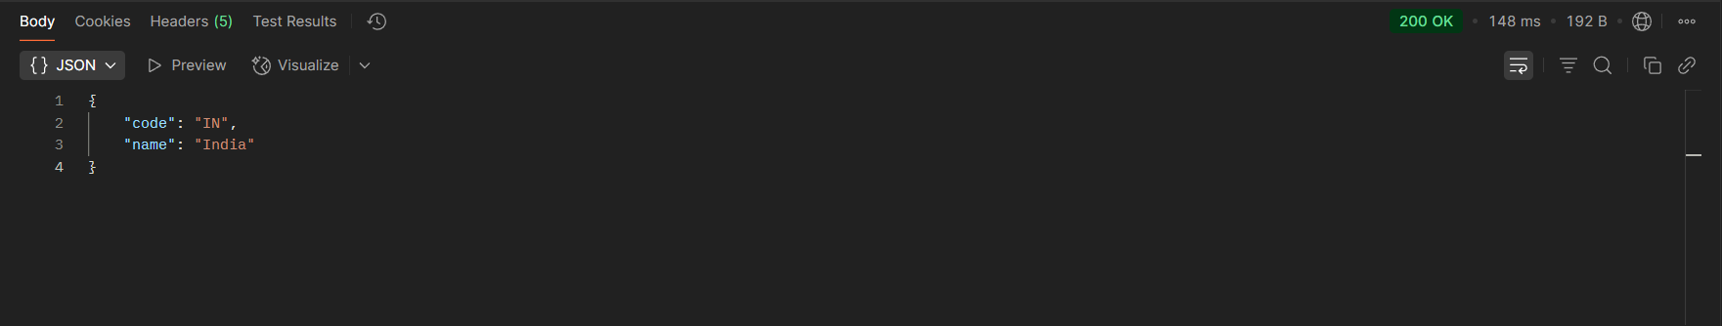

- In network tab of developer tools show the HTTP header details received

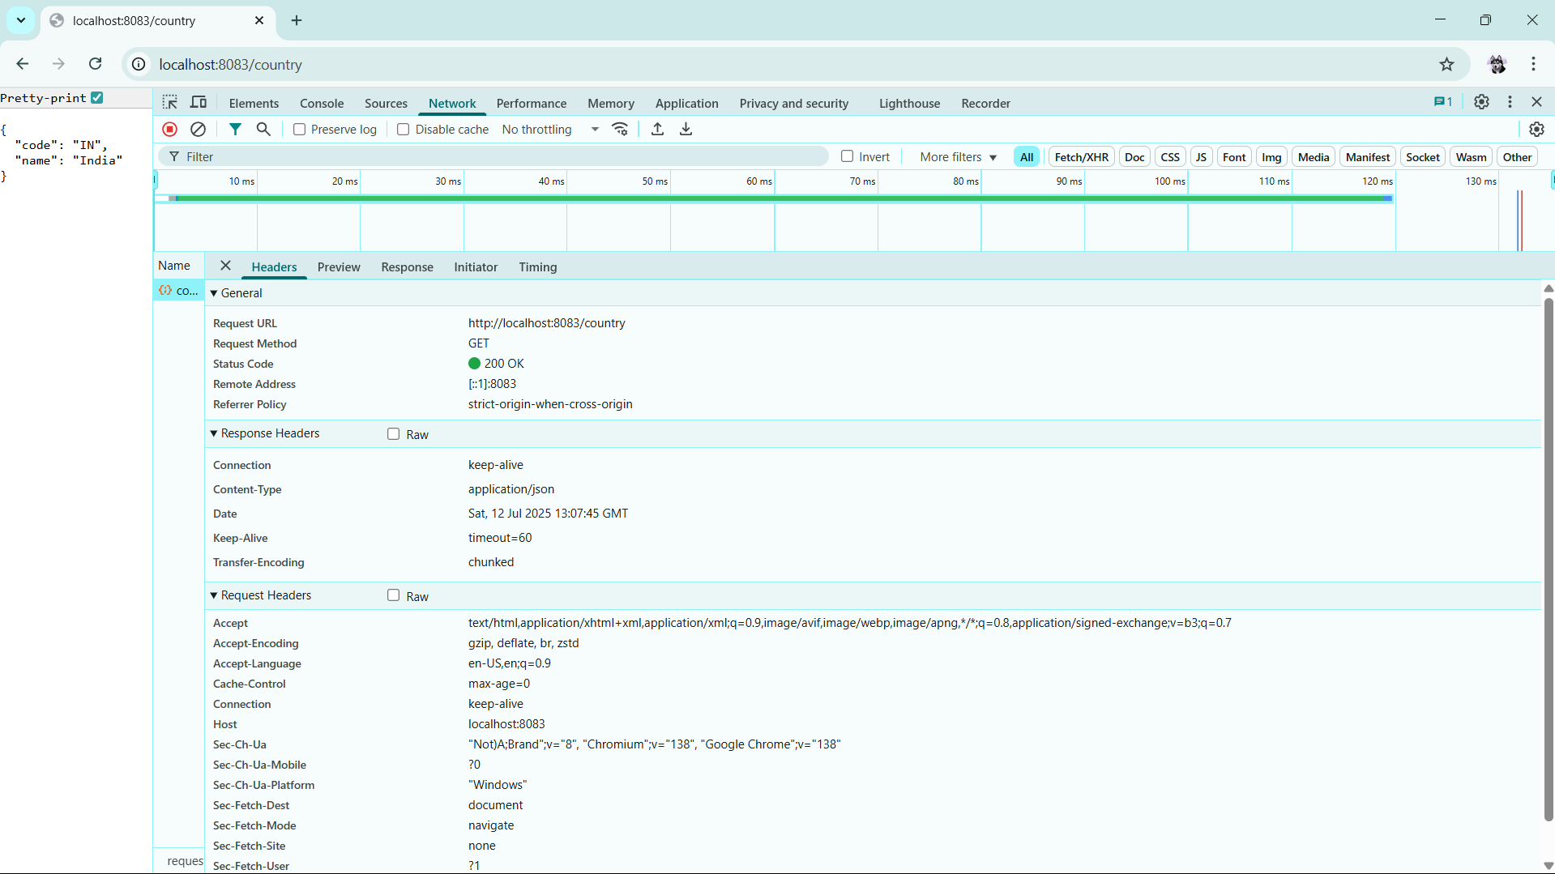

- In postman click on "Headers" tab to view the HTTP header details received

